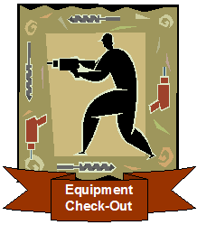

MILESTONE 4 – DATA MODELING AND ANALYSIS

Synopsis
The requirements analysis phase answers the question, “What does the user need and want from a new system?” The requirements analysis phase is critical to the success of any new information system! In this milestone we need to identify what information systems requirements need to be defined from the system users’ perspectives and draw graphical, logical models to document the data requirements for a new and improved system.
Data modeling is a technique for organizing and documenting a system’s data. Data modeling is sometimes called database modeling because a data model is usually implemented as a database. Data is viewed as a resource to be shared by as many processes as possible. As a result, data must be organized in a way that is flexible and adaptable to unanticipated business requirements – and that is the purpose of data modeling.
In this milestone you will first discover those entities in the system that are or might be described by data. Then we will define each entity we identify in respect to the business. Then we will construct a Context Data Model that graphically depicts each of the entities and their relationships with each other. Next, we will refine the context data model to include primary and foreign keys. The resulting model is called a Key-Based Data Model. Finally, we refine the key-based data model to include any hierarchies and attributes, and this model is referred to as the Fully Attributed Data Model.

Objectives
After completing this milestone, you should be able to

- Understand and perform the techniques for entity discovery.
- Define each entity with respect to the business and complete an entity definition matrix.
- Perform the necessary data modeling techniques to organize and document the data requirements for the proposed system.
- Construct the Context, Key-Based, and Fully Attributed data models.

Prerequisites
Before starting this milestone the following topics should be covered:
- Data modeling — Chapter 7.
- Milestone 2 solution.

Assignment
Now that we have studied the current system and analyzed some of its problems and opportunities, plus gained approval to proceed, we can now start to identify the business data requirements and graphically model them. In this assignment we will use our results of the previous Milestone, samples of forms we have collected, and a copy of a transcript of an interview with Dan Stantz’s staff. The results of this activity will identify the business data requirements for the proposed system.

Activities
- Complete an Entity Definition Matrix. Analyze each of the forms referenced by the user interview and make assumptions where necessary. (Note: while it is appropriate to make assumptions, you should document those assumptions and include them in your submission to your instructor.)
- Prepare a Context Data Model.
- Prepare a Key-Based Data Model.
- Prepare a Fully Attributed Data Model including any generalization hierarchies. Add the data attributes for each entity.
Your instructor will specify deliverable format and software to be used. Deliverables should be neatly packaged in a binder, separated with a tab divider labeled “Milestone 4.”

References:

Milestones 1-3 Solution
Provided by your instructor.

Transcripts of Interviews with Equipment Depot staff and Accompanying Sample Forms and Report

Exhibits 4.1–4.4

Templates
See the online learning center website for the textbook.

Deliverables:

Entity Definition Matrix: Due: __/__/__
Time:_______

Context Data Model: Due: __/__/__
Time:_______

Key-Based Data Model: Due: __/__/__
Time:_______

Fully Attributed Data Model: Due: __/__/__
Time:_______

ADVANCED OPTION

For the advanced option, assume (1) that each employee may have multiple skill classifications and (2) this system needs (and has permission) to integrate with the corporate database of all employees that keeps everything ECS needs except skill classification. Your instructor will specify additional system requirements for this part of the system. Modify your initial Entity Definition Matrix and Fully Attributed Data Model to be able to handle this system requirement.

Entity Definition Matrix: Due: __/__/__
Time:_______

Fully Attributed Data Model: Due: __/__/__
Time:_______

Milestone’s Point Value: _______

The following is a copy of the transcripts of an interview between you and Oscar Barrett. The goal of this interview was to obtain sample forms used for processing check-ins and check-outs and to be able to ask questions about them in order to discover data entities of the business system.

Exhibit 4.1

Scene: You have arranged to drop by the Equipment Depot to pick up samples of forms used to process check-ins and check-outs. Oscar Barrett was willing to collect them and answer any questions that you might have.
Oscar: Hi. I assume you are here to pick up the forms.
You: Yes. Is this a good time?
Oscar: Sure. Here are the forms. Any questions?
You: Let’s see . . . I see check-outs on this form (see Exhibit 4.2) but no return. Does that mean that equipment is still out?
Oscar: No. Each time an employee comes to the Equipment Depot counter to conduct business with us, we pull one of these forms out and record all the check-in and/or check-out activity they wish to perform during that visit. It is not intended to be reused when they come back. I’m not sure why we couldn’t use it that way, we just don’t.
You: I see. So the “date” refers to that day’s record of check-in and check-outs for the employee?
Oscar: Well, it is simply the date they are checking in or out the equipment. I know it is a little confusing. Let me give you an example. We would use one of these forms to record all the check-ins and check-outs an employee did in the morning. If that employee returned in the afternoon to return equipment, we would use a new form.
You: Just curious. Why wouldn’t you just pull the form when they come back in and update it?
Oscar: Time! It takes time to look up the form. We do file these, but sometimes they don’t get filed right away. We want to get the employees taken care of as quickly as possible. So it is easier to simply fill out a new one for each visit.
You: But if the new system made it easier to find those records and update them?
Oscar: Yeah, that might make the whole system work better.
You: OK. What is this “employee ID”? Does the Maintenance Department assign that?
Oscar: That is the GB Manufacturing employee ID. All maintenance employees wear an employee ID badge that has their ID and photo. We started that two years ago. It makes things go more quickly. We don’t have to wait for them to pull out their wallets and look up their ID. We can just read it.
You: Do you have to record both the “equip ID” and the “description”?
Oscar: If it is tracked equipment we record the serial number. Those are the equipment we want to specifically track and know who has it.
You: I remember. You have tracked and untracked equipment. Some pieces are too small for an equipment ID and some are too inexpensive to be worth tracking.
Oscar: Exactly. Let’s say we have a particular air compressor and its serial number, 123456789, is stamped on the side. That is an expensive item. We want to track it. We want to know that John Doe has checked out that particular air compressor. We want to know where that particular air compressor is at all times.
You: OK. And you call that tracked equipment?
Oscar: Right. That nailer on the second line is tracked.
You: So what is the “equip id” on the router and bits?
Oscar: We still give everything a numeric ID. It helps us identify them when we are sorting through all these forms. But if we have 10 router and bits sets, they all have the same ID. 1425 means a router and bit set.
You: But if that number isn’t stamped on the equipment as a serial number is, how do you know its number for the form?
Oscar: Oh, we just know most of them. You’d be surprised what sticks in your head over time. But those numbers are also printed on each bin.
You: Bin?
Oscar: Storage bin. All the untracked equipment is organized and stored in numbered storage bins. Bin A48, I think, holds all the router and bit sets, and right on the front of the bin is a card that says Equip ID 1425.
You: Is the tracked equipment also stored in bins?
Oscar: No. Most of them are too large to fit in bins. They are stored in a particular aisle.
You: And you keep all this storage information in your head?
Oscar: We know where all the most popular equipment is stored. But for uncommon requests we refer to this storage list. (see Exhibit 4.3) It shows the aisle or bin location of each kind of equipment. This is just part of it. You can have that.
You: Does some information system generate this list?
Oscar: Just a word processor.
You: What is this “type” column?
Oscar: We categorize the equipment –carpentry, welding, plumbing, machine tools, etc. We have so machine pieces of equipment that those type codes really help us when we’re searching for a particular piece.
You: OK. One more time, let me make sure I understand tracked versus untracked. On this check-out form you know that this employee checked out a router and bit set. But you don’t know which router and bit set.
Oscar: Right. We know which nailer but not which router. Here’s another example and this might clear things up for you. Let’s say that an employee wants checks out a wrench. A wrench is relatively inexpensive. Also, it is virtually impossible to track. A particular wrench does not have a serial number on it! But since it is relatively inexpensive and virtually impossible to track, we don’t even attempt to do so. We simply want to keep track of the fact that the employee checked out a wrench. We don’t care which wrench. We only care that we get the wrench back.
You: OK. Two kinds of equipment and slightly different information kept for each. But everything has an Equip ID.
Oscar: Right. For tracked equipment we only have one piece with that Equip ID. With untracked we could have several.
You: Do you need the system to track the quantity you have of each kind of equipment?
Oscar: Good question. We haven’t until now. If someone calls us up see if we have something in stock we just put him or her on hold and go look. But it would be nice if the computer had a total and could subtract the outstanding loans. Sometimes I’ve suspected people of sneaking in here and raiding our inventory. And maybe your system could even allow people in another plant to check our inventory online before they trudge over here.
You: We’re still working out the system requirements. I’ll write that down. Let’s finish the check-out form. I assume “qty in” and “qty out” for large equipment is always one?
Oscar: That’s correct . . . in fact sometimes we don’t even enter a quantity, since it can’t possibly be more than one.
You: Is “damage” recorded for check-ins or for check-outs or for both?
Oscar: Just for check-ins. If something is damaged enough to not work properly we fix it before it goes out again. Minor damage we just ignore. We don’t care what it looks like as long as it works.
You: OK. Now this employee registration (see Exhibit 4.4) looks pretty understandable. I see you track supervisor.
Oscar: Right. If someone isn’t returning something we go to the supervisor.
You: Are supervisors also employees?
Oscar: Yes. All the maintenance supervisors have to work with their hands, too. So they often check-out equipment. They each have supervisors, but that is one of the maintenance managers.
You: And the supervisor of the maintenance managers is Mr. Venkman.
Oscar: Right.
You: And the classification?
Oscar: That is the employee’s skill classification. Right now we just eyeball that and make sure the equipment being checked out is appropriate for that skill classification.
You: But Mr. Stantz said he wants the new system to track a skill class for each type of equipment and restrict check-outs to employees having that class.
Oscar: Sounds good. But remember that many pieces of equipment could be safely used by employees with any of several skill classifications.
You: That would be a really important point. OK, one last thing. We don’t have a form for the purchases, do we?
Oscar: No. Thankfully, that is all paperless. The only problem with is that the Item IDs used by equipmentdeals.com are not the same as our Equip IDs. That makes tracking orders a pain.
You: I have some good news on that. Equipmentdeals.com has a way to build us a custom web store with our equipment IDs. Plus they can put our order status info into XML that we can use to update our own internal database.
Oscar: I didn’t understand all that. But if you’re saying this solves my order tracking problem, I’m all for it.
You: I think it will solve your problem. You’ll be able to view outstanding orders right within our system.
Oscar: Great!
You: Well, believe it or not, that’s all my questions for now. Thanks for your time.
Oscar: Anytime. I’m excited about this new system.

Exhibit 4.2

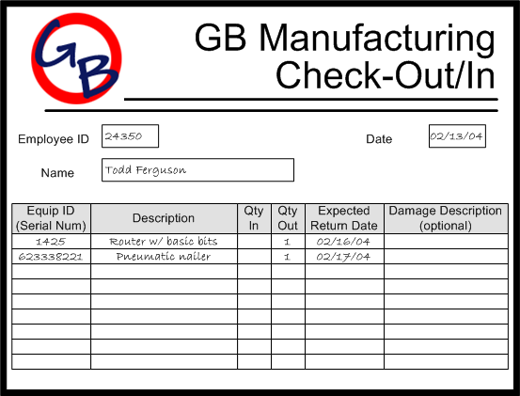

_____________________________________________________________________ __

Exhibit 4.3
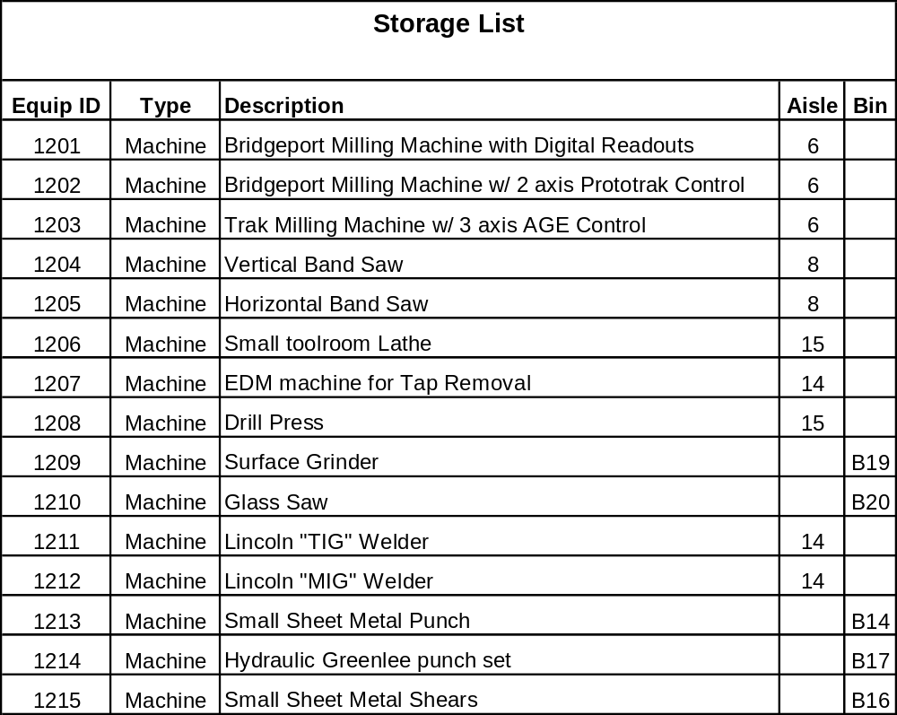

Exhibit 4.4

